WEB
Dot is so big need make it smaler and make poseble to make biger

Some time selected objests is a like It's freezing.
Also after saving canvas objects looks like actyve and saiving this actyve objects

make line creating more friendly, make it like a naw and more flat (naw it sow sensitiv make it without lot of vectors) with toggle button by default make it flat

https://user.climbing.ge/sector_local_images image modal don’t show drowing image it show original image need drowing

also dots size 1 is so big need make size 1 match smolar and make poseble make it biger

also need make sectors drowing system for region all sectors image
on ice article pages sectors and routes is not getting fix it ???????

so I need add 1 col in article table donatid_article. If some article have this item like true need show donation modal on this article page, make migration for thet. Also need modificate articles table with show donation article flag

so naw I need make 2 new tab. One partnior_organithation (not partinior like a article) need add id, name and discount (in %), and partnior_organithation_members with items id, name, surname, email, phon number and organithation_id. Also if this mail olrdi registred need make relation betwin member and user tabs or if member email exist in member bable need also add relation (if need make one more tab for thet) when this member/user make order need make a organithation discount for order. For admin need make new page with permision (also make migration for update permision) for add/edit/del organithation and members and for the user with member relation need show page with thet status and saim organithation enother member lis, show this page just for users who have members relation/status, use admin table component for thet.

So for live cameras I bey a A8 trail camera with ucon app and I need make a show this camera streem on site. I make a mistake and this service don’t have a open api for take data and show it on site but I need make this strem it is wery important for project, I think it poseble to make a android emulator and show this emulator data on web but I bont shure. Need analith my tasw wery deep and for beginning make a plan for do it. Make deep analith it is importent

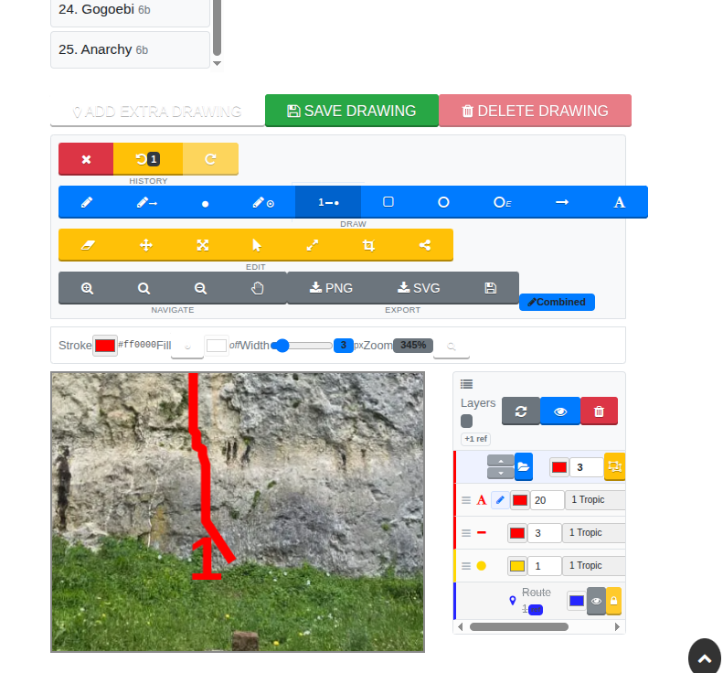

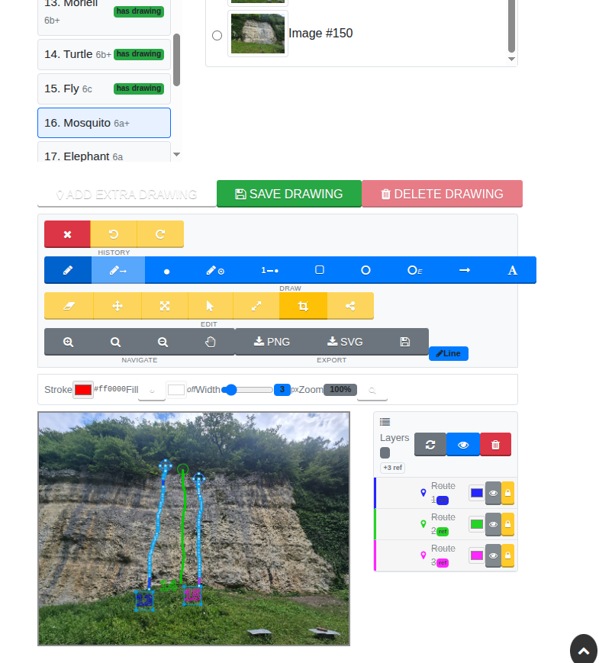

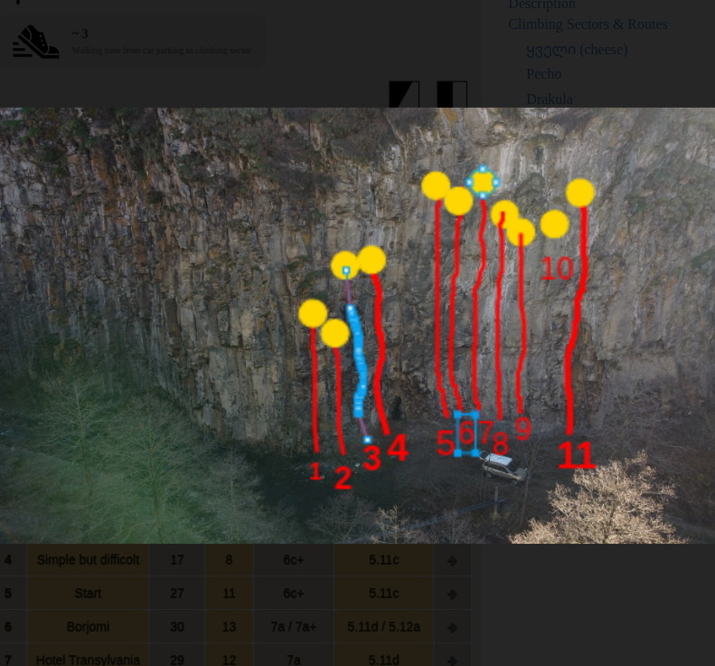
S

